**SIR APOLLO**

**MID TERM III EXAMINATION 2023**

**P.4 INTEGRATED SCIENCE**

***Time Allowed: 2hours 15 Minutes***

**Pupil’s Name: ……………………………………..……………………**

**Class: ……………………………..………………………………………**

**School Name: …………………………………………………………….**

|  |  |  |
| --- | --- | --- |
| **FOR EXAMINERS’**  USE ONLY | | |
| **Qn. No.** | **MARKS** | **EXR’S**  **No.** |
| **1 - 10** |  |  |
| **11 – 20** |  |  |
| **21 – 30** |  |  |
| **31 – 40** |  |  |
| **41 – 43** |  |  |
| **44 – 46** |  |  |
| **47 – 49** |  |  |
| **50 - 52** |  |  |
| **53 - 55** |  |  |
| **TOTAL** |  |  |

**Read the following instructions carefully:**

1. This paper has two sections: **A** and **B**
2. Section **A** has 40 questions (40 marks)
3. Section **B** has 15 questions (50 marks)
4. Answer all questions. All the working for both sections A and B must be shown in the spaces provided.
5. All working must be done using a blue or black ball point pen or ink. Any work done in pencil will NOT be marked except drawings and diagram.
6. Unnecessary changes in your work and handwriting that cannot be easily read may lead to loss of marks.
7. Do not fill anything in the table indicated

**“For examiners’ use only”** and the boxes inside the question paper.

***Turn Over***

**SECTION A**

1. Why do we boil drinking water?

_______________________________________________________________

2. Name the sense organ for tasting.

_______________________________________________________________

3. Which part of air support burning?

_______________________________________________________________

4. What is seed germination?

_______________________________________________________________

_______________________________________________________________

5. Give one way of controlling malaria at home.

_______________________________________________________________

6. Why do insects like bees visit flowers?

_______________________________________________________________

_______________________________________________________________

7. What are weeds?

_______________________________________________________________

_______________________________________________________________

8. Mention one basic need of man.

_______________________________________________________________

9. What is food?

_______________________________________________________________

10. State one way of caring for the body.

_______________________________________________________________

11. How are dogs useful at home?

_______________________________________________________________

12. What scientific name is given to the diagram below?

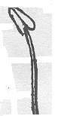

_____________________________________________________

_____________________________________________________

13. Name the gas with the highest percentage in the atmosphere.

_______________________________________________________________

14. What is a balanced diet?

_______________________________________________________________

_______________________________________________________________

15. Name the nutritional deficiency disease caused by lack of proteins in the body of young children.

_______________________________________________________________

16. Mention one characteristic of living things.

_______________________________________________________________

17. Give the use of the garden tool drawn below.

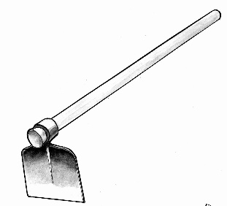

___________________________________________

18. What are crop pests?

______________________________________________________________________________________________________________________________

19. Which part of carrot plant do we eat?

_______________________________________________________________

20. Name the best food for babies.

_______________________________________________________________

21. What are weeds?

______________________________________________________________________________________________________________________________

22. Where do we find germs?

_______________________________________________________________

23. Give one example of a cereal crop.

_______________________________________________________________

24. A woman was found with a swollen neck. What deficiency disease is she suffering from?

_______________________________________________________________

25. What is farming?

_______________________________________________________________

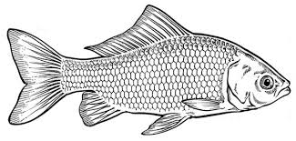 ***Use the diagram below to answer the questions below; 26, 27 and 28***.

26. Mention the habitat for the above animal.

_______________________________________________________________

27. How does it move?

_______________________________________________________________

28. What food value do we get when we eat the above animal?

_______________________________________________________________

29. State one example of a harmful insect.

_______________________________________________________________

30. Give one source of carbohydrates food.

_______________________________________________________________

31. Name the deficiency disease that affects the bones.

_______________________________________________________________

32. What is photosynthesis?

______________________________________________________________________________________________________________________________

33. Give one use of soil to man.

______________________________________________________________________________________________________________________________

34. Why is water important to the body?

_______________________________________________________________

35. Name one method used by weak stems to climb others in order to get enough light.

_______________________________________________________________

36. Name the type of leaf shown in the diagram.

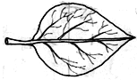

_______________________________________________________________

37. Mention one example of a non-flowering plant.

_______________________________________________________________

38. State one way of caring for the body.

_______________________________________________________________

39. Identify one component of soil.

_______________________________________________________________

40. Why is a maize grain called a fruit and a seed?

_______________________________________________________________

***SECTION B***

41. (a) What mineral salt is needed for the formation of bones and teeth?

_______________________________________________________________

(b) Write the three G (3Gs) in full.

(i) ____________________________________________________________

(ii) ____________________________________________________________

(iii) ___________________________________________________________

42. (a) What is personal hygiene?

______________________________________________________________________________________________________________________________

(b) Name any one item used to promote personal hygiene.

_______________________________________________________________

(c) Identify one group of germs.

_______________________________________________________________

(d) Name one disease that can spread due to poor personal hygiene.

_______________________________________________________________

43. (a) What is weather?

______________________________________________________________________________________________________________________________

(b) Mention any two elements of weather.

(i) _____________________________________________________________

(ii) ____________________________________________________________

(c) What instrument is used to measure the amount of rainfall?

_______________________________________________________________

44. (a) What is air?

_______________________________________________________________

(b) Outline any two components (examples) of air.

(i) _____________________________________________________________

(ii) ____________________________________________________________

(c) What property of air is shown in the diagram below?

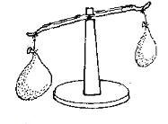

_______________________________________________________________

45. (a) Name one type of germination.

_______________________________________________________________

(b) Mention any two conditions needed for seed germination.

(i) _____________________________________________________________

(ii) ____________________________________________________________

(c) Which gas is given out during seed germination?

_______________________________________________________________

46. (a) Name the best soil for growing crops.

_______________________________________________________________

(b) What type of soil is good for making pot?

_______________________________________________________________

(c) Write down one agent of soil erosion.

_______________________________________________________________

(d) Mention one living organism which lives in the soil.

_______________________________________________________________

47. ***Match A and B***.

**A B**

Carbohydrates Night blindness

Proteins Anaemia

Vitamin A Marasmus

Iron Kwashiorkor

(i) Carbohydrates __________________________________________

(ii) Proteins ________________________________________________

(iii) Vitamin A _________________________________________________

(iv) Iron _________________________________________________

48. ***Use the diagram below to answer the questions that follow***.

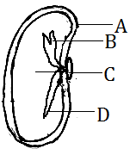

(a) Name parts marked A and B.

(i) A __________________________________________________________

(ii) B ___________________________________________________________

(b) What is the use of part C?

_______________________________________________________________

(c) Which plant system develops from part D after germination?

_______________________________________________________________

49. (a) What is pollination?

______________________________________________________________________________________________________________________________

(b) Identify one agent of pollination.

_______________________________________________________________

(c) State one type of pollination.

_______________________________________________________________

(d) Name the insect that pollinates flowers at night.

_______________________________________________________________

50. (a) What are perennial crops?

______________________________________________________________________________________________________________________________

(b) Mention any two examples of perennial crops.

(i) ____________________________________________________________

(ii) ____________________________________________________________

(c) Name any crop pest which destroys stored food.

_______________________________________________________________

51. (a) What is water cycle?

______________________________________________________________________________________________________________________________

(b) Name any two processes that take place during water cycle.

(i) _____________________________________________________________

(ii) ____________________________________________________________

(c) Give one use of water in our environment.

_______________________________________________________________

52. (a) What are vectors?

______________________________________________________________________________________________________________________________

(b) Mention any two insect vectors.

(i) _____________________________________________________________

(ii) ____________________________________________________________

(c) Why are houseflies dangerous to man?

_______________________________________________________________

53. ***Use the diagram of a leguminous crop to answer the questions***.

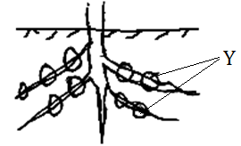

(a) Identify structure Y.

_______________________________________________________________

(b) Mention any two plants with such roots.

(i) ____________________________________________________________

(ii) ____________________________________________________________

(c) Which root system is shown in the diagram?

_______________________________________________________________

54. Give the function of the following garden tools.

(i) Watering can:

_______________________________________________________________

(ii) Trowel:

_______________________________________________________________

(iii) Hoe:

_______________________________________________________________

(iv) Sickle:

_______________________________________________________________

55. Give the use of the following human body organs.

(i) Ears:

_______________________________________________________________

(ii) Nose:

_______________________________________________________________

(iii) Eyes:

_______________________________________________________________

(iv) Tongue:

_______________________________________________________________

***\*\*\*\*\*END\*\*\*\*\****